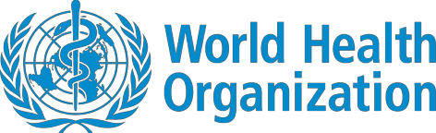

Coronavirus disease (COVID-19)
Situation Report – 103
Data as received by WHO from national authorities by 10:00 CEST, 2 May 2020
This report has been reformatted to improve accessibility for persons with visual impairment.

Highlights
No new country/territory/area reported cases of COVID-19 in the past 24 hours.

WHO and the EuropeanInvestment Bankyesterday signeda collaboration agreement to accelerate investment in healthpreparednessand primaryhealthcare in countries most vulnerable to the COVID-19 pandemic.The firstphase will strengthenprimaryhealthcare in ten Africancountries. The Director- General Dr. Tedros,in hisregular media briefingyesterday saidthat,withthe signingof the agreement, “We are deepening our relationship withthe EuropeanUnion”. He also reminded all that the European Commission will hosta pledgingconference on 4 May to raise funds forinvestment invaccine research.

Situation in numbers (by WHO Region)
Total (new cases in last 24 hours)

Globally | 3 267 184 cases (91 977) | 229 971 deaths (5799)
Africa Americas | 27 973 cases (1310)  1 340 591 cases (48 674) | 1013 deaths (40)  72 196 deaths (3109)
Eastern Mediterranean  Europe | 194 991 cases (6406)  1 492 024 cases (30 620) | 7741 deaths (143)  140 586 deaths (2386)
South-East Asia  Western Pacific | 60 490 cases (3402)  150 403 cases (1565) | 2256 deaths (82)  6166 deaths (39)

Surveillance
Figure 1. Number of confirmed COVID-19 casesreportedin the last sevendays by country, territory or area, 26 April to 2 May**
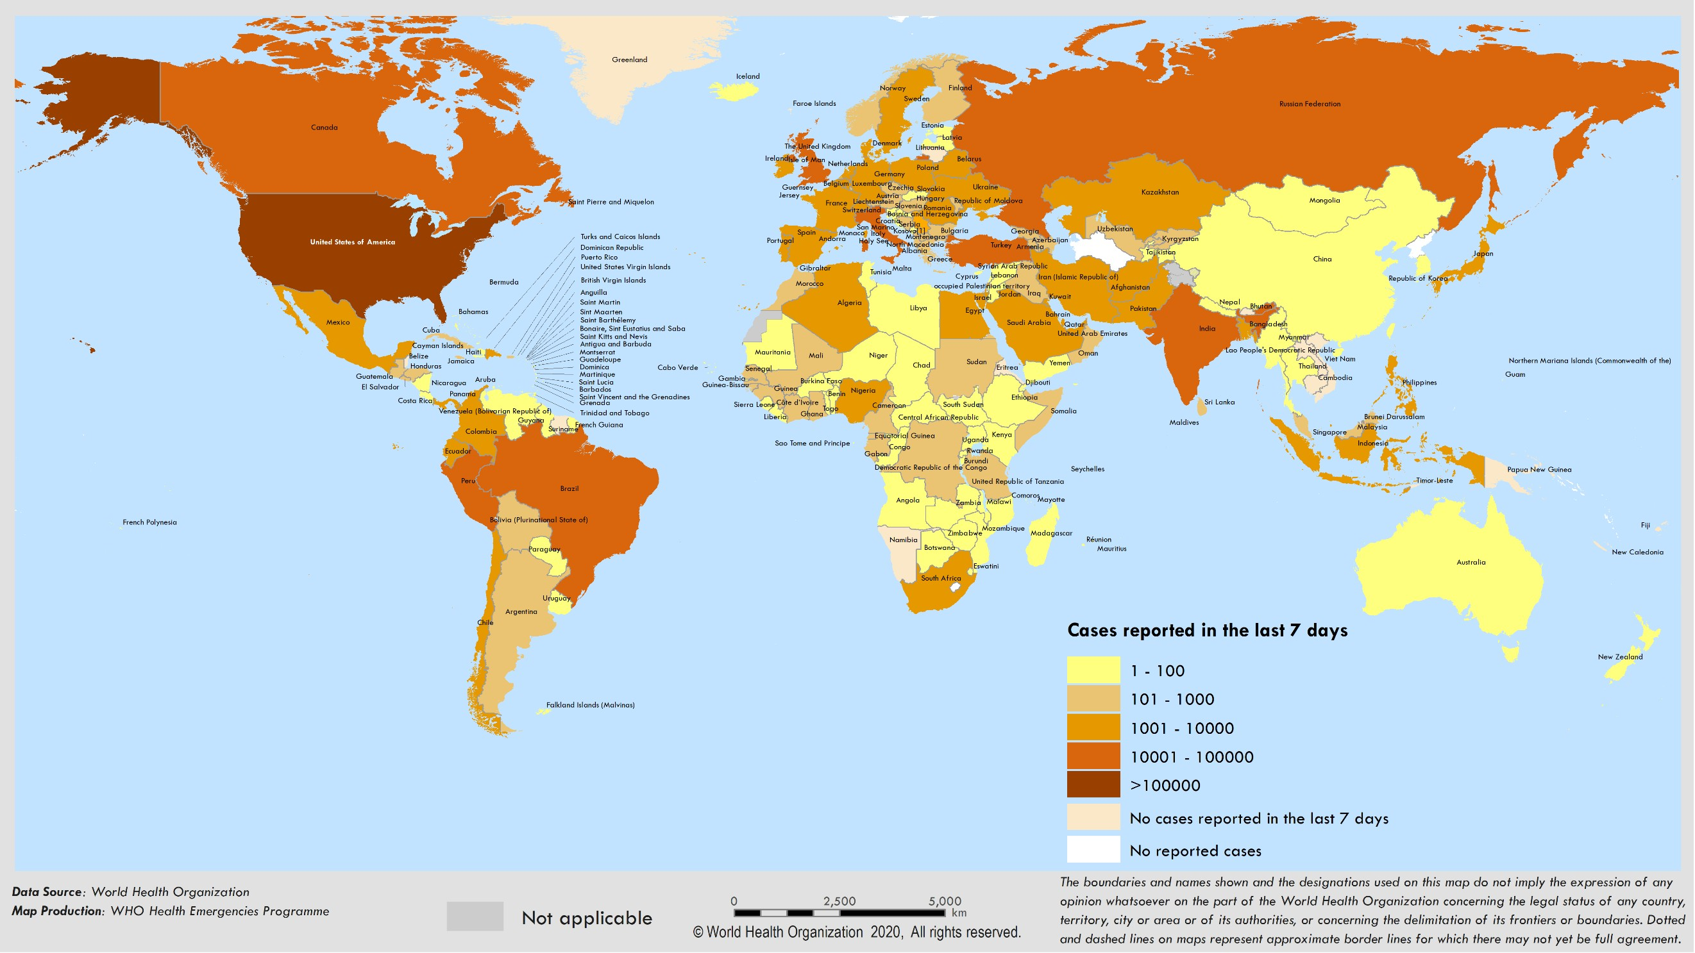
**See Annex 1 for data, table and figure notes.

90000
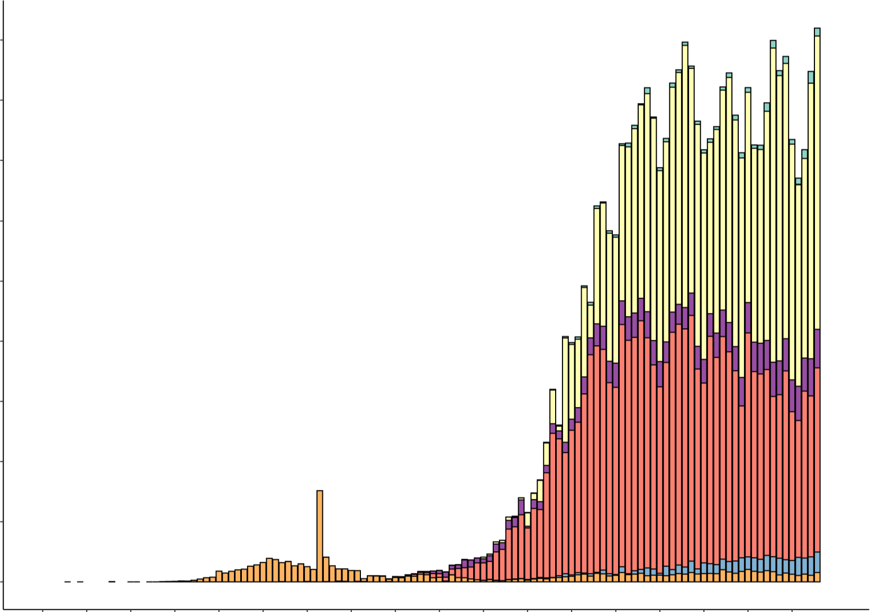

80000

70000

60000

I/) 50000
QI
I/)
(",)'
40000

30000

20000

10000

0

30Dec06Jan13 Jan 20Jan 27Jan 03 Feb10 Feb17 Feb24Feb02 Mar09Mar16 Mar23 Mar30Mar06Apr13 Apr 20Apr 27Apr 2019 2020 2020 2020 2020 2020 2020 2020 2020 2020 2020 2020 2020 2020 2020 2020 2020 2020
Date of report

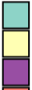
WHO region Africa Americas
Eastern Mediterranean
Europe
South-East Asia Western Pacific Other*

**SeeAnnex 1for data, table and figure notes.

Reporting Country/ Territory/Area | Total confirmed cases | Total confirmed new cases | Total deaths | Total new deaths | Transmission classificationi | Days since last reported case
Africa

South Africa | 5951 | 304 | 116 | 13 | Community transmission | 0
Algeria | 4154 | 148 | 453 | 3 | Community transmission | 0
Nigeria | 2170 | 238 | 68 | 10 | Community transmission | 0
Ghana | 2074 | 0 | 17 | 0 | Clusters of cases | 1
Cameroon | 2069 | 237 | 61 | 0 | Clusters of cases | 0
Guinea | 1537 | 42 | 7 | 0 | Community transmission | 0
Côte d’Ivoire | 1275 | 0 | 14 | 0 | Clusters of cases | 1
Senegal | 1024 | 91 | 9 | 0 | Clusters of cases | 0
Niger | 728 | 9 | 33 | 1 | Clusters of cases | 0
Burkina Faso | 649 | 4 | 44 | 1 | Community transmission | 0
Democratic Republic of the Congo | 604 | 32 | 32 | 1 | Clusters of cases | 0
Mali | 508 | 18 | 26 | 0 | Clusters of cases | 0
United Republic of Tanzania | 480 | 0 | 17 | 0 | Clusters of cases | 2
Kenya | 411 | 15 | 21 | 4 | Clusters of cases | 0
Mauritius | 332 | 0 | 10 | 0 | Community transmission | 5
Equatorial Guinea | 315 | 0 | 2 | 0 | Clusters of cases | 3
Gabon | 308 | 32 | 4 | 1 | Clusters of cases | 0
Guinea-Bissau | 257 | 56 | 1 | 0 | Sporadic cases | 0
Rwanda | 249 | 6 | 0 | 0 | Clusters of cases | 0
Congo | 229 | 9 | 10 | 1 | Clusters of cases | 0
Liberia | 152 | 11 | 18 | 2 | Clusters of cases | 0

Reporting Country/ Territory/Area | Total confirmed cases | Total confirmed new cases | Total deaths | Total new deaths | Transmission classificationi | Days since last reported case

Sierra Leone | 136 | 12 | 8 | 1 | Clusters of cases | 0
Madagascar | 135 | 3 | 0 | 0 | Clusters of cases | 0
Ethiopia | 133 | 2 | 3 | 0 | Clusters of cases | 0
Togo | 123 | 7 | 9 | 0 | Clusters of cases | 0
Cabo Verde | 121 | 0 | 1 | 0 | Sporadic cases | 1
Zambia | 109 | 3 | 3 | 0 | Sporadic cases | 0
Eswatini | 106 | 6 | 1 | 0 | Sporadic cases | 0
Benin | 90 | 6 | 2 | 0 | Sporadic cases | 0
Uganda | 83 | 2 | 0 | 0 | Sporadic cases | 0
Mozambique | 79 | 3 | 0 | 0 | Sporadic cases | 0
Chad | 73 | 0 | 5 | 2 | Sporadic cases | 1
Central African Republic | 64 | 0 | 0 | 0 | Sporadic cases | 1
South Sudan | 45 | 10 | 0 | 0 | Sporadic cases | 0
Eritrea | 39 | 0 | 0 | 0 | Sporadic cases | 13
Malawi | 37 | 0 | 3 | 0 | Sporadic cases | 1
Zimbabwe | 34 | 2 | 4 | 0 | Sporadic cases | 0
Angola | 29 | 2 | 2 | 0 | Sporadic cases | 0
Botswana | 23 | 0 | 1 | 0 | Sporadic cases | 3
Namibia | 16 | 0 | 0 | 0 | Sporadic cases | 26
São Tomé and Príncipe | 16 | 0 | 1 | 0 | Sporadic cases | 1
Burundi | 15 | 0 | 1 | 0 | Sporadic cases | 5
Gambia | 12 | 0 | 1 | 0 | Sporadic cases | 1
Seychelles | 11 | 0 | 0 | 0 | Sporadic cases | 25

Reporting Country/ Territory/Area | Total confirmed cases | Total confirmed new cases | Total deaths | Total new deaths | Transmission classificationi | Days since last reported case

Mauritania | 8 | 0 | 1 | 0 | Sporadic cases | 1
Comoros | 1 | 0 | 0 | 0 | Pending | 1
Territoriesii
Mayotte | 539 | 0 | 4 | 0 | Clusters of cases | 1
Réunion | 420 | 0 | 0 | 0 | Clusters of cases | 2
Americas
United States of America | 1067127 | 31774 | 57406 | 2069 | Community transmission | 0
Brazil | 85380 | 7218 | 5901 | 435 | Community transmission | 0
Canada | 53657 | 1601 | 3223 | 141 | Community transmission | 0
Peru | 36976 | 3045 | 1051 | 108 | Community transmission | 0
Ecuador | 26336 | 1402 | 1063 | 163 | Community transmission | 0
Mexico | 19224 | 1425 | 1859 | 127 | Community transmission | 0
Chile | 17008 | 985 | 234 | 7 | Community transmission | 0
Dominican Republic | 7288 | 316 | 313 | 12 | Community transmission | 0
Panama | 6532 | 154 | 188 | 10 | Community transmission | 0
Colombia | 6507 | 296 | 293 | 15 | Community transmission | 0
Argentina | 4476 | 172 | 220 | 5 | Community transmission | 0
Cuba | 1537 | 36 | 64 | 3 | Clusters of cases | 0
Bolivia (Plurinational State of) | 1167 | 57 | 62 | 3 | Clusters of cases | 0
Honduras | 804 | 33 | 75 | 4 | Clusters of cases | 0
Costa Rica | 719 | 6 | 6 | 0 | Clusters of cases | 0
Uruguay | 643 | 13 | 17 | 2 | Clusters of cases | 0
Guatemala | 599 | 14 | 16 | 0 | Clusters of cases | 0
El Salvador | 424 | 29 | 10 | 1 | Clusters of cases | 0

Reporting Country/ Territory/Area | Total confirmed cases | Total confirmed new cases | Total deaths | Total new deaths | Transmission classificationi | Days since last reported case

Jamaica | 422 | 26 | 8 | 1 | Clusters of cases | 0
Venezuela (Bolivarian Republic of) | 333 | 2 | 10 | 0 | Clusters of cases | 0
Paraguay | 266 | 17 | 10 | 1 | Community transmission | 0
Trinidad and Tobago | 116 | 0 | 8 | 0 | Sporadic cases | 4
Guyana | 82 | 4 | 9 | 1 | Clusters of cases | 0
Bahamas | 81 | 1 | 11 | 0 | Clusters of cases | 0
Barbados | 81 | 1 | 7 | 0 | Clusters of cases | 0
Haiti | 81 | 5 | 8 | 1 | Clusters of cases | 0
Antigua and Barbuda | 24 | 0 | 3 | 0 | Clusters of cases | 9
Grenada | 20 | 0 | 0 | 0 | Clusters of cases | 1
Belize | 18 | 0 | 2 | 0 | Sporadic cases | 17
Saint Lucia | 17 | 0 | 0 | 0 | Sporadic cases | 2
Dominica | 16 | 0 | 0 | 0 | Clusters of cases | 21
Saint Vincent and the Grenadines | 16 | 0 | 0 | 0 | Sporadic cases | 2
Saint Kitts and Nevis | 15 | 0 | 0 | 0 | Sporadic cases | 11
Nicaragua | 14 | 0 | 4 | 0 | Pending | 1
Suriname | 10 | 0 | 1 | 0 | Sporadic cases | 28
Territoriesii
Puerto Rico | 1575 | 36 | 54 | 0 | Clusters of cases | 0
Martinique | 179 | 1 | 14 | 0 | Clusters of cases | 0
Guadeloupe | 152 | 0 | 12 | 0 | Clusters of cases | 1
French Guiana | 128 | 2 | 1 | 0 | Clusters of cases | 0

Reporting Country/ Territory/Area | Total confirmed cases | Total confirmed new cases | Total deaths | Total new deaths | Transmission classificationi | Days since last reported case

Bermuda | 114 | 3 | 6 | 0 | Clusters of cases | 0
Aruba | 100 | 0 | 2 | 0 | Clusters of cases | 9
Sint Maarten | 76 | 0 | 13 | 0 | Clusters of cases | 1
Cayman Islands | 73 | 0 | 1 | 0 | Clusters of cases | 2
United States Virgin Islands | 66 | 0 | 4 | 0 | Clusters of cases | 1
Saint Martin | 38 | 0 | 3 | 0 | Sporadic cases | 9
Curaçao | 16 | 0 | 1 | 0 | Sporadic cases | 4
Falkland Islands (Malvinas) | 13 | 0 | 0 | 0 | Clusters of cases | 6
Turks and Caicos Islands | 12 | 0 | 1 | 0 | Sporadic cases | 4
Montserrat | 11 | 0 | 1 | 0 | Sporadic cases | 18
Bonaire, Sint Eustatius and Saba | 6 | 0 | 0 | 0 | Sporadic cases | 4
British Virgin Islands | 6 | 0 | 1 | 0 | Sporadic cases | 6
Saint Barthélemy | 6 | 0 | 0 | 0 | Sporadic cases | 32
Anguilla | 3 | 0 | 0 | 0 | Sporadic cases | 28
Saint Pierre and Miquelon | 1 | 0 | 0 | 0 | Sporadic cases | 24
Eastern Mediterranean
Iran (Islamic Republic of) | 95646 | 1006 | 6091 | 63 | Community transmission | 0
Saudi Arabia | 24097 | 1344 | 169 | 7 | Clusters of cases | 0
Pakistan | 18114 | 1297 | 417 | 32 | Clusters of cases | 0
Qatar | 14096 | 687 | 12 | 2 | Pending | 0
United Arab Emirates | 13038 | 557 | 111 | 6 | Pending | 0
Egypt | 5895 | 358 | 406 | 14 | Clusters of cases | 0
Morocco | 4569 | 146 | 171 | 1 | Clusters of cases | 0

Reporting Country/ Territory/Area | Total confirmed cases | Total confirmed new cases | Total deaths | Total new deaths | Transmission classificationi | Days since last reported case

Kuwait | 4377 | 353 | 30 | 4 | Clusters of cases | 0
Bahrain | 3170 | 130 | 8 | 0 | Clusters of cases | 0
Oman | 2483 | 36 | 11 | 0 | Clusters of cases | 0
Afghanistan | 2469 | 298 | 72 | 8 | Clusters of cases | 0
Iraq | 2153 | 68 | 94 | 1 | Clusters of cases | 0
Djibouti | 1097 | 8 | 2 | 0 | Clusters of cases | 0
Tunisia | 998 | 4 | 41 | 0 | Community transmission | 0
Lebanon | 729 | 4 | 24 | 0 | Clusters of cases | 0
Somalia | 601 | 0 | 28 | 0 | Sporadic cases | 1
Sudan | 533 | 91 | 36 | 5 | Sporadic cases | 0
Jordan | 459 | 6 | 8 | 0 | Clusters of cases | 0
Libya | 63 | 2 | 3 | 0 | Clusters of cases | 0
Syrian Arab Republic | 44 | 1 | 3 | 0 | Community transmission | 0
Yemen | 7 | 1 | 2 | 0 | Pending | 0
Territoriesii
occupied Palestinian territory | 353 | 9 | 2 | 0 | Clusters of cases | 0
Europe
Spain | 215216 | 1781 | 24824 | 281 | Community transmission | 0
Italy | 207428 | 1965 | 28236 | 269 | Community transmission | 0
The United Kingdom | 177458 | 6201 | 27510 | 739 | Community transmission | 0
Germany | 161703 | 2584 | 6575 | 287 | Community transmission | 0
France | 128722 | 601 | 24560 | 218 | Community transmission | 0
Russian Federation | 124054 | 9623 | 1222 | 53 | Clusters of cases | 0
Turkey | 122392 | 2188 | 3258 | 84 | Community transmission | 0

Reporting Country/ Territory/Area | Total confirmed cases | Total confirmed new cases | Total deaths | Total new deaths | Transmission classificationi | Days since last reported case

Belgium | 49032 | 513 | 7703 | 109 | Community transmission | 0
Netherlands | 39791 | 475 | 4893 | 98 | Community transmission | 0
Switzerland | 29622 | 119 | 1434 | 12 | Community transmission | 0
Portugal | 25351 | 295 | 1007 | 18 | Community transmission | 0
Sweden | 21520 | 428 | 2653 | 67 | Community transmission | 0
Ireland | 20833 | 221 | 1265 | 33 | Community transmission | 0
Israel | 16152 | 148 | 227 | 4 | Pending | 0
Austria | 15531 | 74 | 589 | 5 | Community transmission | 0
Belarus | 14917 | 890 | 93 | 4 | Clusters of cases | 0
Poland | 13105 | 228 | 651 | 7 | Community transmission | 0
Romania | 12567 | 327 | 744 | 27 | Community transmission | 0
Ukraine | 11411 | 550 | 279 | 7 | Community transmission | 0
Denmark | 9311 | 153 | 460 | 8 | Pending | 0
Serbia | 9205 | 196 | 185 | 6 | Pending | 0
Norway | 7759 | 49 | 204 | 0 | Pending | 0
Czechia | 7737 | 55 | 240 | 4 | Community transmission | 0
Finland | 5051 | 56 | 218 | 7 | Pending | 0
Republic of Moldova | 3980 | 83 | 122 | 3 | Pending | 0
Luxembourg | 3802 | 18 | 92 | 2 | Pending | 0
Kazakhstan | 3785 | 234 | 25 | 0 | Pending | 0
Hungary | 2942 | 79 | 335 | 12 | Clusters of cases | 0
Greece | 2591 | 0 | 140 | 0 | Community transmission | 1
Armenia | 2273 | 125 | 33 | 0 | Clusters of cases | 0
Uzbekistan | 2094 | 48 | 9 | 0 | Clusters of cases | 0

Reporting Country/ Territory/Area | Total confirmed cases | Total confirmed new cases | Total deaths | Total new deaths | Transmission classificationi | Days since last reported case

Croatia | 2085 | 9 | 75 | 6 | Community transmission | 0
Azerbaijan | 1854 | 50 | 25 | 1 | Clusters of cases | 0
Iceland | 1798 | 1 | 10 | 0 | Community transmission | 0
Bosnia and Herzegovina | 1757 | 0 | 68 | 0 | Community transmission | 1
Estonia | 1694 | 5 | 52 | 0 | Pending | 0
Bulgaria | 1588 | 82 | 69 | 3 | Clusters of cases | 0
North Macedonia | 1494 | 29 | 81 | 4 | Clusters of cases | 0
Slovenia | 1434 | 5 | 93 | 2 | Community transmission | 0
Slovakia | 1403 | 7 | 23 | 0 | Clusters of cases | 0
Lithuania | 1399 | 14 | 45 | 0 | Community transmission | 0
Latvia | 870 | 12 | 16 | 1 | Community transmission | 0
Cyprus | 857 | 7 | 20 | 0 | Clusters of cases | 0
Albania | 789 | 16 | 31 | 0 | Clusters of cases | 0
Kyrgyzstan | 769 | 13 | 8 | 0 | Clusters of cases | 0
Andorra | 746 | 0 | 43 | 1 | Community transmission | 1
Georgia | 582 | 16 | 8 | 2 | Community transmission | 0
San Marino | 580 | 11 | 41 | 0 | Community transmission | 0
Malta | 467 | 2 | 4 | 0 | Pending | 0
Montenegro | 322 | 0 | 7 | 0 | Clusters of cases | 2
Liechtenstein | 83 | 0 | 1 | 0 | Pending | 6
Monaco | 68 | 0 | 1 | 0 | Sporadic cases | 18
Tajikistan | 32 | 17 | 0 | 0 | Pending | 0
Holy See | 11 | 0 | 0 | 0 | Sporadic cases | 1

Reporting Country/ Territory/Area | Total confirmed cases | Total confirmed new cases | Total deaths | Total new deaths | Transmission classificationi | Days since last reported case
Territoriesii

Kosovo[1] | 813 | 14 | 22 | 0 | Community transmission | 0
Isle of Man | 311 | 0 | 22 | 0 | Pending | 1
Jersey | 290 | 0 | 22 | 2 | Pending | 1
Guernsey | 251 | 0 | 13 | 0 | Community transmission | 1
Faroe Islands | 187 | 0 | 0 | 0 | Pending | 8
Gibraltar | 144 | 3 | 0 | 0 | Clusters of cases | 0
Greenland | 11 | 0 | 0 | 0 | Pending | 26
South-East Asia
India | 37336 | 2293 | 1218 | 71 | Clusters of cases | 0
Indonesia | 10551 | 433 | 800 | 8 | Community transmission | 0
Bangladesh | 8238 | 571 | 170 | 2 | Pending | 0
Thailand | 2966 | 6 | 54 | 0 | Clusters of cases | 0
Sri Lanka | 690 | 25 | 7 | 0 | Clusters of cases | 0
Maldives | 468 | 72 | 1 | 1 | Clusters of cases | 0
Myanmar | 151 | 0 | 6 | 0 | Clusters of cases | 1
Nepal | 59 | 2 | 0 | 0 | Sporadic cases | 0
Timor-Leste | 24 | 0 | 0 | 0 | Clusters of cases | 8
Bhutan | 7 | 0 | 0 | 0 | Sporadic cases | 9
Western Pacific
China | 84388 | 3 | 4643 | 0 | Clusters of cases | 0
Singapore | 17101 | 932 | 16 | 1 | Clusters of cases | 0
Japan | 14545 | 264 | 454 | 22 | Clusters of cases | 0
Republic of Korea | 10780 | 6 | 250 | 2 | Clusters of cases | 0

Reporting Country/ Territory/Area | Total confirmed cases | Total confirmed new cases | Total deaths | Total new deaths | Transmission classificationi | Days since last reported case

Philippines | 8772 | 284 | 579 | 11 | Clusters of cases | 0
Australia | 6767 | 5 | 93 | 1 | Clusters of cases | 0
Malaysia | 6071 | 69 | 103 | 1 | Clusters of cases | 0
New Zealand | 1134 | 2 | 20 | 1 | Clusters of cases | 0
Viet Nam | 270 | 0 | 0 | 0 | Clusters of cases | 7
Brunei Darussalam | 138 | 0 | 1 | 0 | Sporadic cases | 12
Cambodia | 122 | 0 | 0 | 0 | Sporadic cases | 20
Mongolia | 38 | 0 | 0 | 0 | Sporadic cases | 5
Lao People's Democratic Republic | 19 | 0 | 0 | 0 | Sporadic cases | 19
Fiji | 18 | 0 | 0 | 0 | Sporadic cases | 11
Papua New Guinea | 8 | 0 | 0 | 0 | Sporadic cases | 9
Territoriesii
Guam | 142 | 0 | 5 | 0 | Clusters of cases | 1
French Polynesia | 58 | 0 | 0 | 0 | Sporadic cases | 4
New Caledonia | 18 | 0 | 0 | 0 | Sporadic cases | 29
Northern Mariana Islands (Commonwealth of the) | 14 | 0 | 2 | 0 | Pending | 14

Other* 712 0 13 0 - 47
Subtotal for all regions | 3 266 472 | 91 977 | 229 958 | 5799

Grand total | 3 267 184 | 91 977 | 229 971 | 5799

**See Annex 1 for data, table and figure notes.
Technical guidance and other resources
- To view all technical guidance documents regardingCOVID-19, please go to this webpage.
- Updates from WHO regional offices

– WHO AFRO | – WHO PAHO
– WHO EMRO | – WHO SEARO
– WHO EURO | – WHO WPRO

- Research and Development
- Online courses on COVID-19 and in additional national languages
- The Strategic Preparedness and Response Plan (SPRP) outlining the support the international community can provide to all countries to prepare and respond to the virus.
- WHO Health Emergencydashboard
- Weekly COVID-19 Operations Updates

Recommendations and advice for the public
- Protect yourself.
- Questionsand answers
- Travel advice
- EPI-WIN: tailored information for individuals, organizations and communities

Case definitions
WHO periodically updates the Global Surveillance for human infection withcoronavirusdisease (COVID-19) documentwhich includes surveillance definitions.
Definitionof COVID-19 death
COVID-19 death is defined for surveillance purposesas a death resulting from a clinically compatible illness in a probable or confirmedCOVID-19 case, unlessthere is a clear alternative cause of death that cannot be relatedto COVID disease (e.g.trauma).There should be no period of complete recovery betweenthe illness and death.
Annex 1: Data, table and figure notes
Caution must be taken when interpreting all data presented. Differences are to be expected betweeninformation productspublished by WHO, national public health authorities, and other sources using different inclusioncriteria and different data cut-off times. While steps are taken to ensure accuracy and reliability, all data are subject to continuous verification and change. Case detection, definitions, testing strategies,reporting practice, and lag times differ between countries/territories/areas. These factors, amongst others, influence the counts presented with variable underestimation of true case and death counts,and variable delays to reflecting these data at global level.
The designations employed, and the presentation of these materialsdo not imply the expressionof any opinion whatsoever on the part of WHO concerning the legal status of any country, territoryor area or of its authorities, or concerning the delimitation of its frontiersor boundaries. Dotted and dashed lines on maps represent approximate border lines for which there may not yet be full agreement. Countries,territories and areas are arranged under the administering WHO region.
[1] All references to Kosovoshould be understoodto be in the context of the United Nations Security Council resolution 1244 (1999).
In the map, number of cases of Serbia and Kosovo (UNSCR 1244, 1999) have been aggregated for visualizationpurposes.

Counts reflect laboratory-confirmedcases and deaths, based on WHO case definitions unless stated otherwise (see Country, territory, or area-specific updates anderrata),and include bothdomestic and repatriated cases.
Other*: includes cases and deaths reported under the international conveyance (Diamond Princess).
Additional table notes
i Transmission classification is based on a process of country/territory/area self -reporting. Classifications are reviewed on a weekly basis,may be revised as new information becomes available,and are based on the highest category reported. Differing degrees of transmission may be present within countries/territories/areas. Categories:
- No cases: with no confirmed cases(not shown in table).
- Sporadic cases: withone or more cases, imported or locallydetected.
- Clusters of cases:experiencing cases, clustered in time, geographic location and/or by common exposures.
- Community transmission: experiencinglarger outbreaks of local transmission defined through an assessment of factorsincluding, but not limited to: large numbers of casesnot linkable to transmission chains; large numbers of casesfrom sentinel lab surveillance; and/or multiple unrelatedclusters in several areas of the country/territory/area.
- Pending: transmission classification not been reported to WHO.
ii “Territories” include territories,areas, overseasdependenciesand other jurisdictions of similar
status.

Country, territory, or area-specific updates and errata
None

